NAME:- MUHAMMAD ZOHAIB AHMER. (FA20-BCS-038)

SANAN (SP20-BCS-038).

DATED :- 2023.12.27

CC LAB TERMINAL

Q1: Description of the project??

ANS:

The primary focus revolves around the intricate automation of strings, alphabets, and related elements. The design encompasses a sophisticated system that not only manipulates but also interprets and transforms various types of strings. The automation processes intricately define the handling of alphanumeric sequences, ensuring efficiency and precision in their manipulation. Each step of the automation is meticulously crafted to provide a seamless experience, with the ability to process diverse sets of strings with varying complexities. The alphabet, a fundamental component of linguistic structures, undergoes a tailored automation process that accounts for linguistic nuances, ensuring accurate and contextually relevant transformations. The output of this automation project displays each meticulously crafted step, offering transparency into the inner workings of the system. This project represents a significant stride in the realm of string manipulation and alphabet automation, providing a versatile and powerful tool for applications ranging from linguistic analysis to data processing.

Q2: Which functions is used ??

ANS:

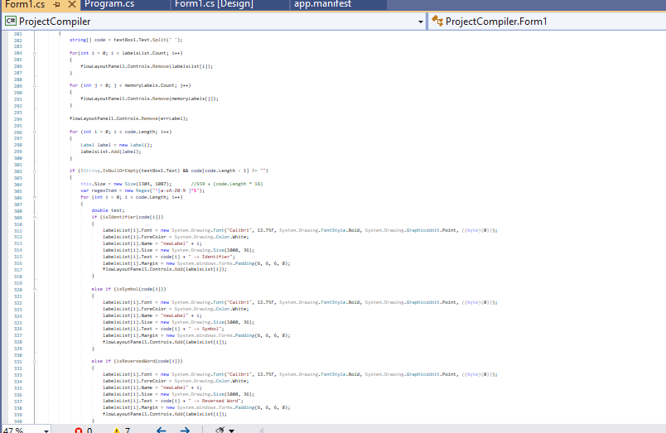

Output:

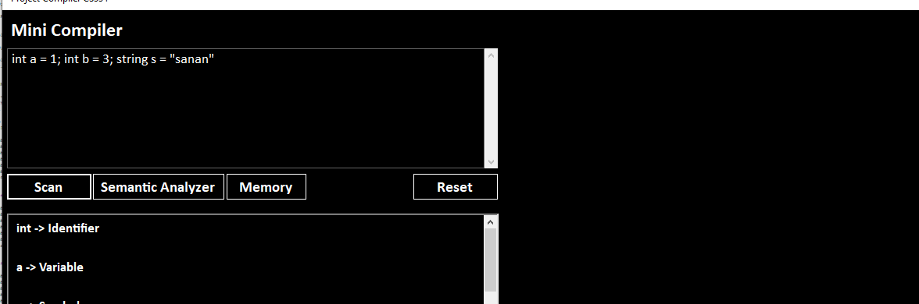

Q3: Show the input

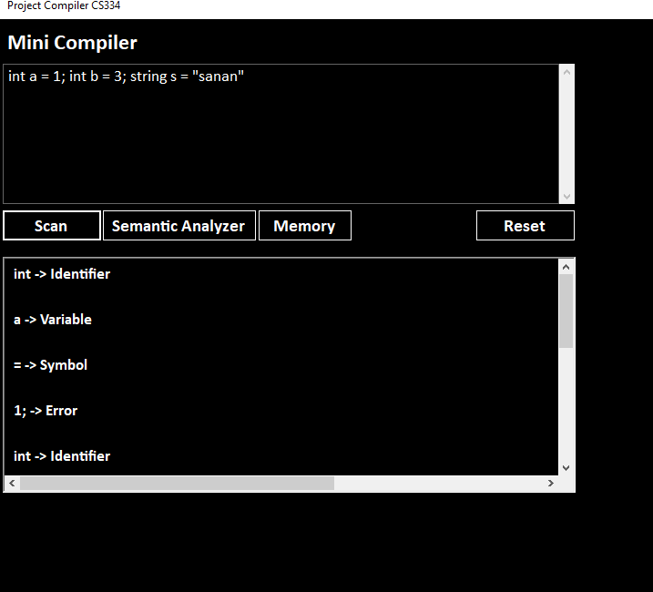

Symantic analysis

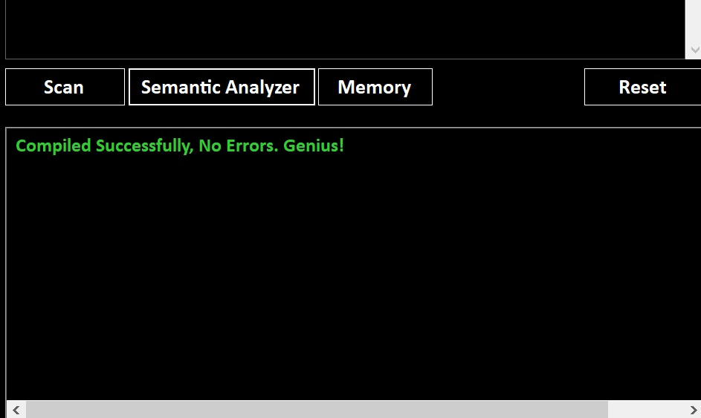

Q4:How function works?

Ans:-The provided C# code defines a method named main Analyze that takes an integer parameter which Button and returns a boolean value. The method is designed to analyze code input from a TextBox . It splits the input into an array of strings, initializes some variables, and proceeds to analyze the code in a loop. The analysis involves checking for identifiers, variables, and specific keywords.

Q5:- what challenges your faces during the project ?

Ans:-The challenges we faced during the project were:-

Designing the Abstract Syntax Tree (AST):

Creating a well-structured AST that accurately represents the grammar of the programming language can be challenging.

Lexical Analysis and Tokenization:

Implementing a robust lexical analyzer to break down the source code into tokens might involve dealing with irregularities and edge cases.

Syntax Parsing:

Designing and implementing a parser to analyze the syntax of the language and generate a valid AST can be challenging, especially for complex grammars.

Error Handling:

Developing a comprehensive error-handling mechanism to provide meaningful error messages to users can be demanding.

Code Generation:

Generating efficient and correct code from the AST can be a complex task, especially when dealing with optimizations and target-specific code generation.

Optimizations:

Implementing optimization techniques to improve the performance of the generated code can be challenging, requiring a deep understanding of compiler optimizations.

Debugging and Testing:

Debugging a compiler can be challenging due to the layers of abstraction involved. Developing effective testing strategies, including unit tests and integration tests, is crucial.

Documentation:

Maintaining clear and comprehensive documentation for the compiler, including the language specification, can be time-consuming but is essential for users and future developers.

Compatibility and Portability:

Ensuring that the compiler works correctly on various platforms and with different input programs can be challenging for achieving broad compatibility.

Learning Curve:

If the team is not familiar with compiler construction, there might be a learning curve to understand the principles and best practices in building compilers.

Project Scope Management:

Managing the scope of the project to avoid feature creep and focusing on essential functionalities can be challenging.